AI-Based Advanced Approaches and Dry Eye Disease Detection Based on Multi-Source Evidence: Cases, Applications, Issues, and Future Directions

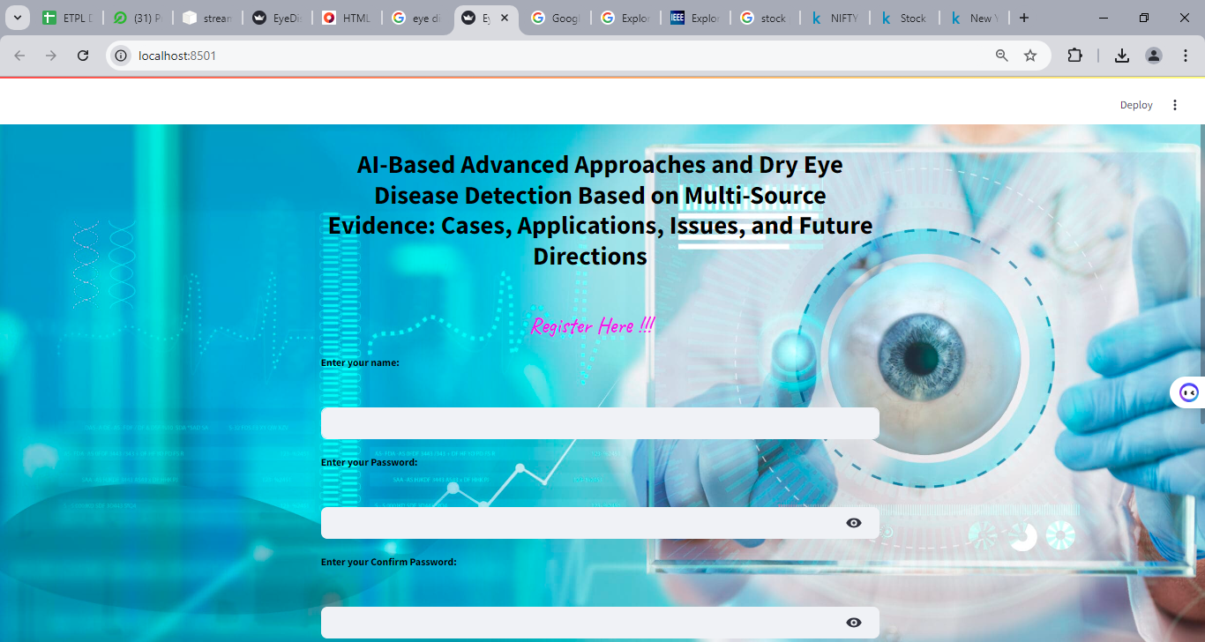
This is the register page, here the user can register the page based on credentials such as Name, password, confirm password and email and stored in database


This is the register page, here the user can register the page based on credentials such as Name, password, confirm password and email and stored in database

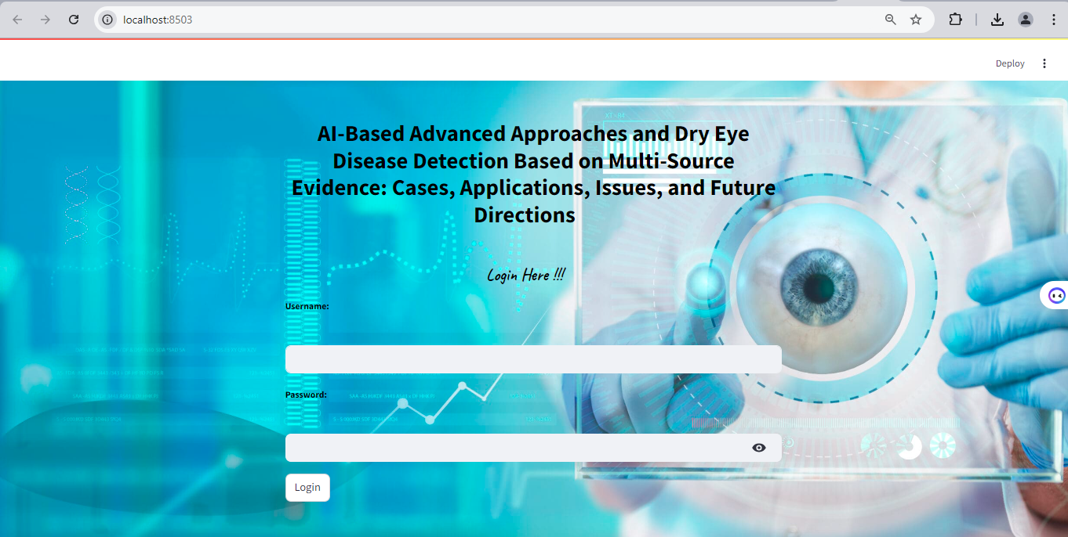

This is the login page, here the user can enter the registered credentials for access the page


This is the prediction page, here the user can choose either dry eye prediction, eye disease prediction or eye blink detection

Dry Eye Prediction:
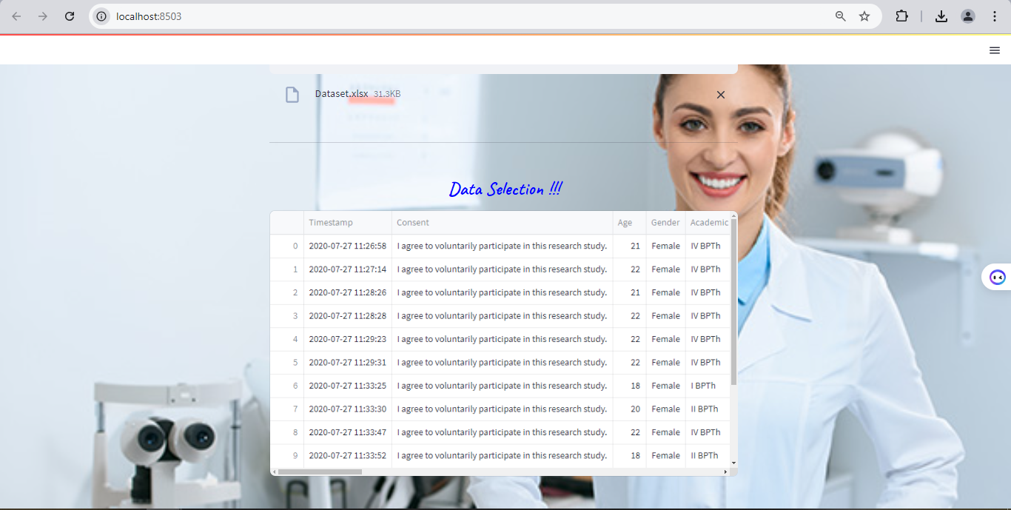
This is the dry eye prediction page, here the user can upload the input data and display the sample of dataset


This is the preprocessing step in dry eye prediction page, the system can missing values.


This is the preprocessing step in dry eye prediction page, the system can missing values and replace the missing values.


This is the preprocessing step in dry eye prediction page, the system can display before label encoding.


This is the preprocessing step in dry eye prediction page, the system can display after label encoding.


This is the data splitting step in dry eye prediction page, the system can split the dataset into test and train .

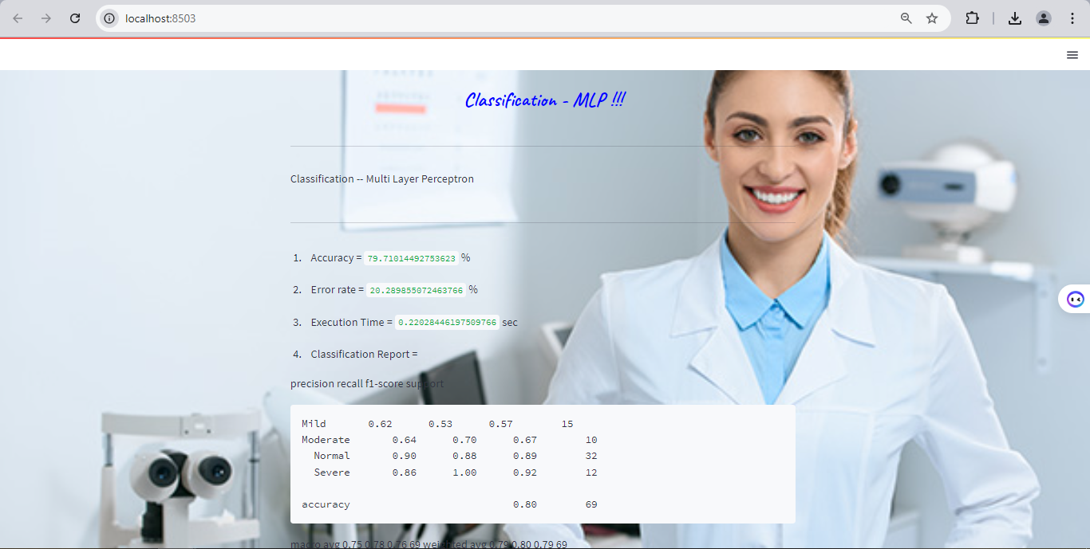
This is the classification step in dry eye prediction page, here we are used MLP and got 79% accuracy.


This is the prediction step in dry eye prediction page, based on the user’s input prediction number, the system will be predicted and it shows affected as moderate.

Eye Disease Prediction:



This is input upload page in eye disease prediction.



This is input page in eye disease prediction, here the user can upload the input image from dataset and display the input image.

This is pre-processing page in eye disease prediction, in this step, the system can implement the image resize and gray scale conversion.


This is feature extraction and image splitting page in eye disease prediction, in this step, the system can shows the extracted features value and splitted data.


This is classification and prediction page in eye disease prediction, in this step, the system can show accuracy and predicted result.

Eye Blink Prediction:


This is input upload page in eye blink prediction.



This is input page in eye blink prediction, here the user can upload the input image from dataset and display the input image.


This is pre-processing page in eye blink prediction, in this step, the system can implement the image resize and gray scale conversion.



This is feature extraction and image splitting page in eye blink prediction, in this step, the system can shows the extracted features value and splitted data.

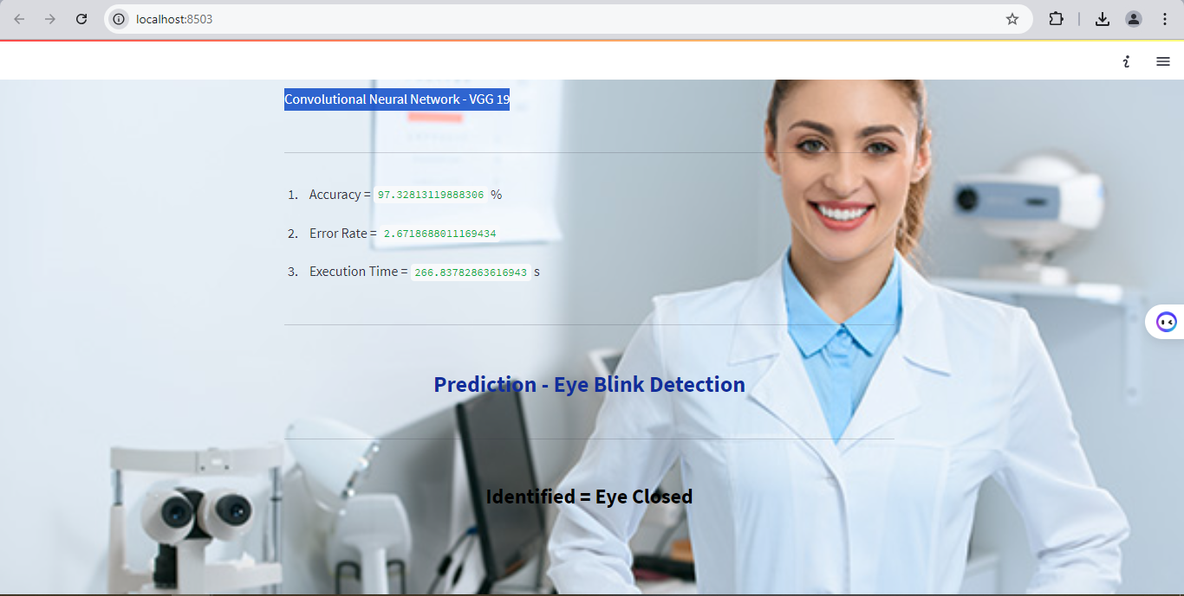

This is classification and prediction page in eye blink prediction, in this step, the system can show accuracy and predicted result.

